Caution Roadblocks Ahead!
Hosting a Design Driven Social Innovation
Lab in a Research-Intensive University
Abstract: This paper presents the process of setting up a Design-driven Social Innovation Lab in the Design Department at The Ohio State University. The authors discuss the challenges and roadblocks of developing the Lab, and provide a strategic roadmap to surpass them. Because project grounded research still has an ill-defined place in the scientific research landscape, setting up a social innovation lab in a Tier 1, research-intensive university has challenges both seen and unseen. For instance, colleagues across the university may not be aware of how design can be a tool for social change. Additionally, peers evaluating tenure-track faculty may not recognize social design as scholarship but view it only as service and community outreach. In order to overcome these challenges, the authors present an action framework to structure the relationship between community engagement and project grounded research to advance scholarship in social design. This framework serves as a way to reconcile misconceptions around the scientific value of project-based research and close the gap in language between the grammar of project-based design and academic research in the Usonian context.

Theme: TOGETHER, THE NEED FOR A SHARED LANGUAGE?
Keywords: Design Research, Social Innovation, Academia, Project Grounded Research

1. Introduction
Over the past fifteen years, we have witnessed a development for social awareness among many design schools. Design departments across the globe have started to host social innovation labs as a way to structure project grounded research (Findeli, 2015; Stappers, 2007) activities and foster partnerships between their programs and community organizations. The labs hosted under the umbrella of the DESIS network are models of this kind of structure (Manzini, 2014). An Innovation Lab typically engages with initiatives intended to tackle contemporary issues relevant to a particular community. The initiatives may be project-based or research led with direct engagement with community partners or indirect involvement; in either scenario, the resultant aim is that the community is the beneficiary of the study and work.
However, because project grounded research still has an ill-defined place in the scientific research landscape (Gauthier, 2015), setting up a social innovation lab in a research-intensive university has several challenges and faces many roadblocks. One such roadblock is the reflex, particularly of academic peers, to consider the engagement activities hosted by the innovation lab only in terms of service and community outreach (Leaman, 2014). Project grounded research, while a strand of action research, is dismissed as less rigorous than scientific research methods. What is missing then from this limited view is the recognition that university-community partnerships can advance teaching and learning, promote research and scholarship, and serve communities in tangible ways toward real social changes. The collective “service” labeling of activities spawned within innovation labs creates communication obstacles among faculty, administrators, and funding organizations. This limits; 1) the attractiveness of these labs as research-intensive sites, especially for junior tenure-track faculty under pressure to build their research publication track, 2) access to grant opportunities, especially from federal agencies like the National Science Foundation (NSF) and the National Institute of Health (NIH), and 3) the capacity to engage in cross-disciplinary exchange and transdisciplinary scholarship. The challenge then is to structure a clear roadmap for an Innovation Lab to advance scholarship and research, extend education beyond the campus, and cultivate sustained community partnerships for authentic impact.
This paper will lay the foundation of a framework capable of bridging the conceptual gap between the nature of project grounded research activities and the typical community-led innovation lab projects, and confront what is traditionally valued and expected of scholars at Tier 1 Research intensive universities.
Launching into the process of developing a design-driven social innovation lab in the Department of Design at The Ohio State University, we discuss how grammars of projects and research may be reconciled. We argue that project topics should be considered in terms of a general research axis. Aligning projects within a research axis framework addresses terminology usage and resonates in a language more common in academia. Within such a framework, language barriers are at least minimized if not eliminated, and cross-pollination of research methods is more effective for a large array of disciplines, such as sociology, political science, gerontology and so forth to engage peers outside of a design discipline to participate. Small steps such as these allow project based research to adjust to the context of activation and enable design to engage in interdisciplinary dialogue in academia.

2. Background

2.1 The purpose of Design Driven Social Innovation Lab
The complexity of social and environmental issues, combined with a rapidly changing global economy within the information age has given rise to a variety of challenges for design professionals. Designers work with and on problems, finding or developing opportunities from which to offer solutions. Designers are also those who engage in design thinking which is a similar process but where the scale and complexity of the problem is much larger and the response may not be a physical object (Pendleton-Jullian, 2009). So, although we see tremendous growth of research activities carried out by design professors, researchers and scholars outside the field of design do not always know what design-driven research is, or what contributions design thinking and design doing might have on the pressing problems we face today. In the United States, there continues to be preconception that designers, in practice and academia, are primarily concerned with form. Yet, “notions of the scope of design action have changed.” (Poggenpohl, Sato, 2009, p. 8). As expressed in their critical essay on the shifting landscape of the discipline of design, Sharon Poggenpohl and Keiichi Sato state:
Some designers have moved from the aesthetic configuration that typically happens near the end of a project to the beginning where what may develop is unknown. Here another kind of process unfolds, one initially divorced from physical making and more deeply engaged with processing information and understanding context through the generation of frameworks or conceptual diagrams, defining the problem to be addressed, asking questions, accessing research, constructing new research, and entertaining possibilities (Poggenpohl, Sato, 2009, p. 8).

2.2 The Ohio State University, a land-grant and Tier-1 Research intensive university
As a Tier 1 research and land-grant institution, The Ohio State University (OSU) is uniquely positioned to support a Design Driven Social Innovation Lab. The resources, infrastructure, and established community partnerships (locally and globally) make it an ideal environment to sow the seeds for a forward-thinking, interdisciplinary design-driven innovation lab. First, the resources available are extensive. With 17 Colleges across various disciplines, the university boasts the intellectual capital of more than 40,000 distinguished scholars and staff. As one of the largest universities in the United States, the institute has an undergraduate population of more than 52,000 students and 13,000 students enrolled in graduate and postgraduate programs. Second, the university hosts infrastructure for advanced centers of learning and think tanks that serve as hubs of academic exchange. In addition to this, there is a comprehensive medical center combined with a teaching hospital. Yet, perhaps most significant, is the fact that OSU is a public land-grant university. As such, the university has a long-standing mission to uphold the Morrill Act of 1862, which states that the U.S. Congress “provide grants of land to states to finance the establishment of colleges specializing in ‘agriculture and the mechanic arts.’ With a historical mission to serve the populace through education extension, The Ohio State University has developed local, regional, national, and international partnerships with community organizations to educate beyond the campus walls. This is precisely the type of fertile ground necessary to cultivate the seeds for research-informed, design-driven innovation lab toward sustainable social change. As an intensive, ‘very high research focused university, the tier 1 research ranking of OSU makes it one of the top 2.5% institutions of higher education’ among all others in the United States.” The criterion upon which institutes of higher education earn the tier 1 research rank also contributes to the fertility of developing a design-driven social innovation lab at OSU. These metrics include, the receipt of grants and contracts over $1 million dollars a year, the award of upwards of 200 doctoral degrees a year, an increase in research scientist staff (funded through grants and contracts), and graduate rates that exceed the national average of 55%.

2.3 Roadblocks to the establishment of a Social Innovation Lab
All of these factors would seem to make OSU the ideal place to conceive of establishing a research intensive, transdisciplinary design driven social innovation lab. However, challenges and roadblocks are present and require careful navigation. For all the positive elements and potential OSU appears to have to host a design-driven social innovation lab, there are major barriers that need to be confronted and addressed. Of these, preconceptions, terminology use, and language barriers are the most challenging obstacles, particularly in a research-intensive setting. Preconceptions among scholars outside the field include knowing what Design is and lacking awareness of what design thinking methodologies are and how their use and implementation can be sources to complex problem solving within traditional research-intensive settings, because research methods are traditionally codified with a scientific approach.
This has a bit to do with the history and development of design programs within the United States. Typically design programs were formed from schools of fine art from a Beaux Arts tradition. The specific contextual setting for OSU is a case in point. In fact, the burden of the department of design and the preconceptions it may harbor among faculty outside the discipline may be due to its historical founding. Prior to its independence as a stand-alone department at OSU, the study of design fell within the study of Art. In its inception, design was an area within the School of Art. Traditionally designers were artisan-craftsman; in addition to their craft-trade background, many were formally trained within a master-apprenticeship studio environment. Therefore, based on this historic precedent, the alliance of design to the School of Art was logical. However, as the field of product design expanded and grew to include studies in visual communications and interior design with a human-centered design approach, its’ philosophical approaches shifted from art and it became apparent that the discipline of “design” should be independent from the School of Art (Gysler, Jones, and Wallschlaeger, 1972).
Despite the fact that design research has evolved greatly over the last few decades (Joost et al., 2016), preconceptions remain about what design is good for. A wide number of colleagues outside design remain oblivious of how design could be utilized for problem identification and problem solving. This has complicated the establishment of research collaborations with other disciplines. Combined with the fact that academic peers are also unsure of how rigorous design research methods are makes it challenging for design scholars to see their work valued and recognized. This, in turn, makes it challenging for design faculty to see their work acknowledged. Access to research funding from the two main research funding agencies in the United States is significantly more complicated. Unlike Canada where designers have a proven track record of accessing research grants from either one of the three scientific research councils—Social Sciences and Humanities Research Council (SSHRC), Natural Sciences and Engineering Research Council (NSERC) and Canadian Institutes of Health Research (CIHR)—design researchers in the U.S. mainly have to rely on the National Endowment for the Arts (NEA) to fund their research endeavor. This proves to be particularly limiting. For instance, NEA grants are often insufficient to cover the hiring cost of skilled research fellows. Moreover, it can become problematic for promotion and tenure of junior faculty. Specifically, the dossier of design faculty in the College of Arts & Sciences is compared to dossiers of faculty from disciplines with highly structured systems of research production. Additionally, colleagues from disciplines, such as psychology, sociology or biology, are the ones reviewing the scholarship and research production of the design faculty member. Both of these are considerable challenges that must be met.

3. Setting up a Design Driven Innovation Lab at The Ohio State University
Despite challenges and roadblocks, we are convinced that Design driven social innovation labs can provide a legitimate and effective structure to support academic research endeavors about social innovation. Moreover, our decision to pursue the establishment of a social innovation lab is motivated by the nature of some of OSU’s design faculty research activities. For the past eight years Susan Melsop has been organizing and championing an OSU sanctioned service learning collaborative studio called Design Matters (Melsop, 2010). During the first four years, the course bought together urban youth with Ohio State students to co-design and build small-scale structures, furniture pieces, and landscape elements for a community art center on the East side of Columbus, Ohio. Each project was completed by university students and youth from the Transit Arts program, an arts-based, youth development program for urban teens. Since 2017, the course has moved to São Paulo, Brazil where OSU’s design students partner with fellow students from Mackenzie Presbyterian University and together work with a marginalized population to design and build projects for a homeless resource center. Other faculty members also conduct project-based research and develop partnerships with organizations like public libraries (Abrassart et al., 2015) and sustainable retail stores (Matheny, 2016); topics range from public health and the visually impaired.
As we argued, these kind of partnerships and projects are valued as they represent good teaching environments and they directly contribute to improving the lives of community members. Moreover, we believe they represent good research settings to examine and analyze the activity of design. As argued by Proulx, Gauthier & Hamarat, (2017) using students’ work is a common strategy in design research.
For one, many emergent fields of practice in design stem from academic research and in that sense universities offer the only context where one can access the data needed to describe and analyze such practices and their outcomes. […] Moreover, educational environment offers a very flexible context where ideal forms of practices can be experimented and assessed. Of course, such strategy entails a few shortfalls due to unrealistic experimental conditions. One might well argue that the stakes facing real practice can never be matched through educational curriculum. Also, by definition, students, however good they are, seldom show the same level of proficiency than seasoned professionals. (Proulx, Gauthier & Hamarat, 2017, p. 995)
But to avoid the pitfalls and roadblocks identified, an organisational framework allowing to carry a research agenda is needed. In this last part of the paper we present the strategy envisions for establishing such lab structure in the Design Department at The Ohio State University. (See Figure 1)
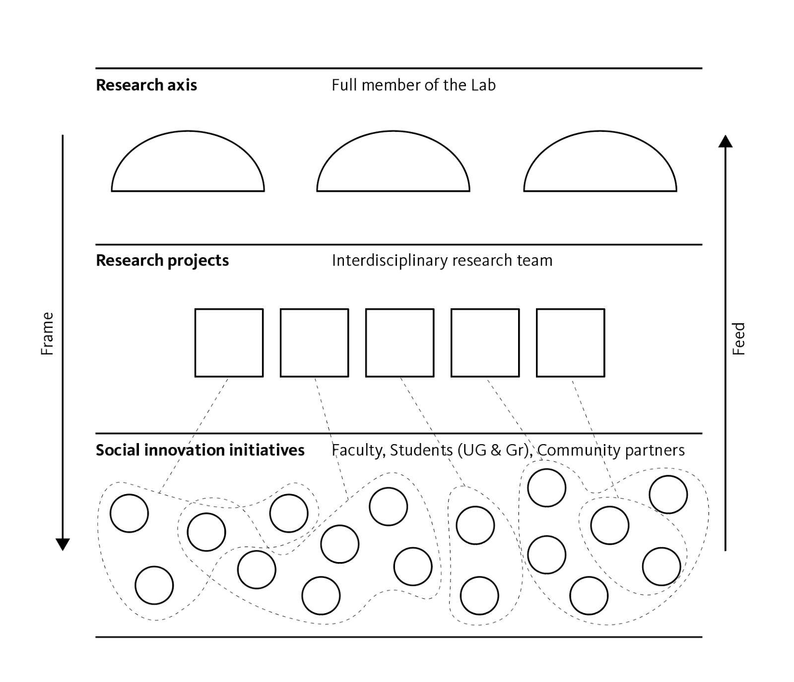
Figure 1. Three levels action framework of the OSU Design Driven Social Innovation Lab.

3.1 The action framework
To become legitimate and respected as a genuine research setting, the work within a social innovation lab must remain focused on the objective of generating new knowledge and training future designers and scholars. Anyone involved in research through projects faces the significant challenges of getting caught up by the design project pitfalls and losing track of scientific research objectives and methodological requirements. Providing a community partner with satisfying results is a mandatory requirement for Social Innovation Labs. Failing to do so would be unethical due to the university-community investment in the project. Therefore, it is essential to maintain equilibrium between conducting rigorous scientific research and providing an impactful design service action to the community partner. The challenges are therefore to develop a win-win-win balanced setting that 1) promotes scientific research and advances the field of desiegn, 2) encourages learning to happen in-situ, and 3) provides benefits to partners.
The organizational model envisioned is a three-level structure (see figure 1). Due to the nature of design-driven research activities, this organizational model can be read and utilized either from top-down or bottom-up system. Indeed, despite its vertical nature, this organizational model is meant to allow projects to emerge from community-led commissions as well as from theoretical hypothesis within academia. For the sake of clarity, we will here present the organizational model from the bottom-up perspective, a logic more common to design community readers for whom this paper is foremost intended.
Level 1—Social Innovation Initiatives
At the first level sit community based design projects. These projects can be initiated by a researcher pursuing a partner for specific research and teaching endeavour or be commissioned by a community partner. Although, in the latter situation it will be expected that the initiative be associated to an ongoing research project or give rise to a new one. This is a safeguard intended to help filter the multiple opportunities we are often presented with to avoid the multiplication of project types that don’t serve academic purposes or the scientific agenda of members of the lab.

Level 2—Research Projects
Research project sits at the second organizational level. Research projects are led by members of the lab on individual or collaborative basis. As with any research project, their goal is the advancement of knowledges (epistemological, methodological, operational). Research projects may also take different forms, from casuistic study to critical analysis to experimental research. The idea is that no community base projects can be undertaken without a corresponding structured research project. Publishing and dissemination expectation are also expected to ensure that research objectives are met. For instance, all design projects are expected to be documented and presented at conferences. Research projects outcomes also have to be disseminated. On top of that, research leaders are expected to show that their projects and findings are contributing factors to the examination of the research axis. Failing to produce outcomes, or producing outcomes unrelated to the specified research axis, may lead to the dismissing of a project. Once again this is a safeguard intended to ensure that research and scientific agenda remain central focus of the lab.
Level 3—Research Axis
Finally, at the top level are the research axes representative of the interests of all full members of the lab. These research axes are conceptual umbrellas intended to conceptually frame the relationship between social innovation initiatives and their corresponding research project. A research axis provides an effective way to think about i) intertwining social innovation initiatives and research projects, ii) pursuing heuristic objectives, iii) engaging academics that are not familiar with research through project based methodologies.

3.2 Safeguard ensuring the integrity of research activities
The objectives of such an organizational model are threefold. First, research and dissemination standards serve as a safeguard ensuring that the university doesn’t become an unfair competitor to consultant agencies. In an emerging field such as social innovation there is a risk that university with faculty on payroll and graduate trainee cannibalize the emergent field of social innovation and prevent the rise of a sustainable “market.” We believe that academics are legitimate when they engage in social innovation initiatives for they have a role to play in expanding the horizon of design activities. As argued by Tonkinwise (2016) “the Idea of the University is that they should always be going against what the market is doing. The job of the University is to think about things the market cannot” (4:37-4:52). Moreover, we also believe that academics have the responsibility to train students by providing them experiential learning in the field with real community benefactors.
Secondly, this three-level structure is envisioned as a way to foster collaboration and help bring together researchers’ activities. It is intended to facilitate partnerships and mitigate terminology differences that often accompany cross-disciplinary teams while ensuring that the lab remains a living environment capable of adapting to its members’ evolving objects of concern. We are cognizant of the fact that contemporary issues are complex and multifaceted; they give rise to new concerns and that some opportunities will present themselves organically. As we remain open to such possibilities, a new research axis can develop while the established ones may transform or be completely abandoned. The safeguards are not intended to lock things up. They are there to facilitate dialogue among researchers, community partners and within and beyond academia.
Finally, and most importantly, we consider this structure to be an effective way to create a setting that enables scholars, especially those from outside the field of design, to find an intelligible research space that is also a convenient setting for them to advance their research activities and ultimately their scholarship. Therefore, we believe that embracing research through project-based initiatives this lab structure will cultivate fertile land for unique, cross-disciplinary exchange and foster the emergent of genuine interdisciplinary dialogue for real and sustained social innovation.

4. Reconciling the grammars of project and research
The research axes as conceptual lenses are intended to lay the ground for effective coordination among researchers from different intellectual cultures around the research questions and social innovation initiative. We consider the umbrellas as positive factors capable of bridging gaps in language and terminology between the kind of research done by designers with the scientific paradigm more common in academia.
Our lab will first be structured around three axes: 1) ethics, 2) epistemology of design practice, 3) socio-politics of design. Project-based works set around the Ethics axis will focus on the moral responsibilities that come tangentially to all social innovation initiatives. This axis is also closely bound to the issue of training designers capable of sustaining those moral responsibilities. The Epistemology of Design Practice axis is intended to frame reflection from a metacognitive standpoint (i.e., how do we know what we know) and analyze projects to a better access and understand a designerly way of thinking and doing (Cross, 2007) in projects aimed toward social innovation. Finally, the Sociopolitical axis will consolidate research projects focusing on the analysis of social innovation and the longitudinal and intrinsic value these types of design activities have.
As conceptual umbrellas, the research axes have trickle down effects to frame the research projects and social innovation initiatives. On the other side, the social innovation initiatives give rise to first-hand information fed from the research activities.

Conclusion
While it can be debated whether or not design research should play by the rules of academia and scientific research, we have to live by them for the time being. Both promotion and tenure committee and research funding from Federal Agencies have a word on setting the standards by which contemporary scholarly activities are evaluated. The challenges remain: is it possible to play by those rules and still be capable of engaging in research through design projects?
In this paper, we discussed the ongoing project of establishing of design-driven social innovation lab in the Design Department at The Ohio State University. We presented the specificity of a Tier 1 Research intensive university and the roadblocks that such a context presents for design research. We posited that for research through design to happen and be valued for what it is, there is need to organize activities in ways more fitted to current standards of academia. On that matter, we presented the organizational model (an action framework) we envision to structure our lab activities. We demonstrated how we intend to “protect” the scientific agenda by setting certain safeguards. Moreover, we argued that our three-level model provides the sort of grammatical structure capable of bridging the gap between design-driven research and academia. In other words, the framework provides a mechanism for a shared language to emerge and enables social innovation initiatives to become not only an object of study but also a genuine context to study.

References
Abrassart, C., Gauthier, P., Proulx, S., & Martel, M. (2015). Le design social: une sociologie des associations par le design ? Le cas de deux démarches de codesign dans des projets de rénovation des bibliothèques de la Ville de Montréal [Social Design: a Sociology of Association Through Design? The Case Study of Two Codesign Activity Commission by the City of Montreal for the Renovation of Public Libraries]. Lien social et Politiques, (73), pp. 117-138.
Cross, N. (2007). Designerly ways of knowing. Board of International Research in Design. Basel: Birkhäuser.
Findeli, A., Brouillet, D., Martin, S., Moineau, C., & Tarrago, R. (2008, May). Research through design and transdisciplinarity: A tentative contribution to the methodology of design research. In Focused. Swiss Design Network Symposium (pp. 67–91). Berne, Switzerland: Swiss Design Network.
Findeli, A. (2015). La recherche-projet en design et la question de la question de recherche: essai de clarification conceptuelle [Searching for Design Research Questions: Some Conceptual Clarifications]. Sciences du Design, (1), pp. 45-57.
Gauthier, P. (2015). Création contre science en design, les conditions d’un vrai débat: réponse à Lysianne Léchot Hirt [Creation Against Science in Design, The Conditions for the Genuine Debate: An answer to Lysianne Léchot Hirt]. Sciences du Design, (2), pp. 65-70.
Gysler, R.L., Jones, S.O. and Wallschlaeger C. (1972) A Rationale and Structure for the Discipline of Industrial Design with Implications for Product, Visual Communication and Space and Enclosure Design Education. A Prospectus for the Faculty of the Division, The Ohio State University, Columbus, Ohio.
Joost, G., Bredies, K., Christensen, M., Conradi, F., & Unteidig, A. (Eds.). (2016). Design as Research: Positions, Arguments, Perspectives. Board of International Research in Design. Basel: Birkhäuser.
Leaman, M. (Ed.) (2014). Trends in social innovation education 2014. Ashoka U.
Lemieux, C. (2009). Le devoir et la grâce [Duty and Grace]. Collection “Étude sociologique, Paris: Économica.
Manzini, E. (2014). Making things happen: Social innovation and design. Design Issues, 30(1), pp. 57–66.
Matheny, R. (2016, February). Meanings and Memories through Retail Storytelling: A Case Study of Two ‘Generous Brands’’ Stories of Authentic Sensorial Immersion. Paper presented at the 10th Design Principles & Practice International Conference, Rio de Janeiro.
Melsop, S. (2010). Community Design Matters: A New Model of Learning. Design Principles & Practice: An International Journal, 4(6), pp. 41–56.
Pendelton-Jullian, A. (2009). Design Education and Innovation Ecotones. Available: https://fourplusone.files.wordpress.com/2010/03/apj_paper_14.pdf. (Last accessed, January 12, 2018).
Poggenpohl, S. H., & Satō, K. (Eds.). (2009). Design integrations: research and collaboration. Chicago: University of Chicago Press, Intellect Books.
Proulx, S., Gauthier, P. & Hamarat, Y. (2017). Qualities of Public Health. Towards an Analysis of Aesthetic Features of Public Policies. In: Vogel, C. & Muratovski, G. (Eds.) Re: Research (pp. 992-1006). University of Cincinnati, OH: IASDR Conference.
Stappers P.J. (2007). Doing Design as a Part of Doing Research. In: Michel R. (ed.) Design Research Now (pp. 81–98). Board of International Research in Design. Basel: Birkhäuser.
Tonkinwise, C. (2016, January 15). Sharing Economies for Design the Future [video file]. Retrieved from https://design.cmu.edu/content/cameron-tonkinwise-talks-sharing-economies-design-future (Last accessed, January 5, 2018.)

Community is a complex and loaded concept. As suggested by Lemieux (2009), community can be described as “the horizon called by any action or any judgment.” In the context of this paper, we more prosaically refer to the community in reference to agents outside of academia.
Land-Grant institution are publicly funded college and university.
https://www.osu.edu/osutoday/stuinfo.php#enroll
https://www.unlv.edu/sites/default/files/assets/toptier/docs/UNLV-School-Handout.pdf
http://carnegieclassifications.iu.edu
We are here adopting the perspective of Findeli and colleagues (2008) who described transdisciplinarity as interdisciplinarity turn into project.
For instance, while there are some PhD programs in Design in the United States, the National Association of School of Art & Design (NASAD) still recognize the Master of Fine Arts (MFA) as the professional terminal degree for the the discipline of design. For more detail see: https://nasad.arts-accredit.org/wp-content/uploads/sites/3/2016/03/NASADPolicyAnalysis-Thinking-about-Terminal-Degrees-in-AD.pdf
In the United States they are the National Science Foundation (NSF) and the National Institute Health (NIH).
In 2016 Emily Carr University of Art + Design, a small institution dedicated to art and design, was awarded a Foundation Grant by the Canadian Institutes of Health Research (CIHR), to finance its Health Design Lab. See: http://research.ecuad.ca/healthdesignlab/about/
https://design.osu.edu/people/melsop.3
Collaborative studio refers to studio activities engaging student from OSU’s all three design majors: Industrial Design, Interior Design and Visual Communication.
I chose to partner with the non-profit, Central Community House on the Eastside to engage their urban youth in design-build projects as a way to extend architecture and design education to a vulnerable population. The Eastside of Columbus is predominately African-American; it has traditionally been considered an underserved neighborhood with a college graduation rate of less than 36% and yet its residents live within seven miles of a land-grant university.

